**Crop Prediction App: Machine Learning-Based Forecasting for Optimal Crop Selection Using Climate, Soil Conditions and other factors.**

Gunda Sri Harini

12/05/2023

# ABSTRACT

The Crop Prediction App is an progressive innovative idea and product, that leverages gadget gaining knowledge of techniques to provide accurate crop selection suggestions primarily based on historical yield data, season, type of soil, water contents, nutrient contents in the soil, previous crop, weather patterns, pest and disease outbreaks, and market demand. By making use of a robust dataset comprising historical weather data, soil homes, and crop performance metrics, the app employs superior algorithms to are expecting and optimize crop selections for agricultural stakeholders. The app integrates real-time weather records sourced from climate stations, satellites, and forecasts, blended with comprehensive soil facts gathered through soil trying out and mapping. Machine studying algorithms examine this numerous dataset to become aware of problematic styles, correlations, and developments, allowing particular predictions for crop suitability. This app also provide customized recommendations based on individual farmers' circumstances.

Overall, it is a application product that helps farmers regarding crop management and keep away from loss by way of giving the satisfactory recommendations according to the provided data.

# Problem Statement

Agriculture is one of the constructing blocks of the economy. It gives food and raw materials for the millions of human beings within the global. Farmers face numerous challenges in coping with their crops due to the unpredictable weather patterns, soil erosion, degradation…and so on. By utilizing gadget mastering algorithms, predictive analysis and records, the product can provide accurate tips on the vegetation to grow and whilst to plant and harvest them well. How ever, collecting the information and records is

time eating however the final results could be very beneficial for farmers in making better final results and earnings.

# Market/Customer/Business need Assessment

In the market, there's a drought for innovative gear and technology, that could assist farmers in crop management and growing productivity. The crop prediction app is designed to serve the needs of farmers, mainly in growing countries, which have got limited get admission to agriculture technologies. By supplying farmers with accurate and customized outcomes on the crops to develop and the way to grow and a way to manipulate them correctly, the app can help these business increase their income. Additionally, the app can help permit farmers to increase extra powerful products and offer better services to satisfy their desires.

Overall, it additionally performs a good-sized function in growing the economy via agriculture by validating all of the vegetation such that products produced will be the same because of the call for and export, through this there will not be any united states of America and downs inside the yield of the uncooked material produced. So, there'll not be any loss and no wastage of uncooked fabric

# Target Specification

* + Accuracy and reliability: The app have to deliver farmers correct and reliable pointers for coping with their plants if you need to increase their yields.
  + Usability and accessibility: The app want to be easy to apply and reachable to farmers of all stages of era experience and literacy.
  + Customization and personalization: The app want to be capable of provide customized recommendations primarily based on a farmer's area, soil type, and to be had sources.
  + Integration with present technology: The app need to be capable of work with the other device farmers use, like irrigation and nutrient manipulate tools.
  + Cost-effectiveness: The app need to be inexpensive for farmers, specially the ones in developing countries.

# External Search

The sources I have used as reference for analyzing the need of such a system for small and large farmers in India and how giants in other country have been using the technique to boost up their yields and profits, have mentioned below :

* + Understanding soil,climate conditions and user inputs.
  + How crop prediction benefit farmers.
  + Crop prediction Analysis explained.
  + Increasing Customers and Improving Quality of product to maximize outcome of the product.
  + A study on Understanding Changing Trends of Customer Behaviour and hence the Market.

# Bench marking

Benchmarking a crop prediction app involves evaluating its performance and evaluating it with different existing solutions or enterprise standards. Here are some key components to not forget while benchmarking a machine gaining knowledge of primarily based on crop prediction app.Data collection, model selection, training validation, feature importance, Comparison with baselines, Scalability and Efficiency, User feedback and accuracy, Robustness, generalization comparative analysis, and Continuous improvements. By thinking about those components and conducting a comprehensive assessment, you can efficaciously benchmark a crop prediction app and decide its performance in comparison to other solutions within the area.

# Applicable Patents

* **Patent 1: Crop prediction based on soil and environmental characteristics using feature selection techniques**

There are a lot of patents that can be looked upon, but since this relate the most to the application of crop prediction. The patent describes in detail the crop prediction Technique and how it has been used for generating best crop prediction based on the farmers input behaviour and identified from the applicable dataset, according to predetermined attributes. It also describes the rules generated by the algorithm to group the environmental conditions together. The patent describes an enhanced model ,they look into a various wrapper feature and choice of strategies.Their model of Crop prediction is done using classification techniques that advise the correct crops for land. The experimental effects display the Recursive Feature Elimination method with the Adaptive Bagging classifier outperforms the others.The above model will be significantly considered while developing and implementing a similar system for accuracy in the prediction of the crop.There are a lot of patents that can be looked upon, but since this relate the most to the application of Crop prediction mentioned above, I have mentioned them.

# Applicable Constraints

* + Data availability: The accuracy and reliability of the app's predictions rely upon the supply of correct and up to date records on factors which includes soil kind, water content, nutrient content material, and weather patterns.
  + Technical constraints: The app might also need to be well matched with various devices and running structures, which may additionally require additional development and checking out. Additionally, the app's overall performance may be confined by using the processing electricity and reminiscence of users' devices.
  + Cost: The price of developing and maintaining the app can be a constraint, specially for startups or small groups with confined economic assets. Additionally, the price of accessing records and integrating with different technology can be prohibitive in certain regions.
  + Language and cultural barriers: The app may need to support multiple languages and be touchy to cultural differences to be able to effectively reach and interact farmers in different regions.
  + Regulatory and criminal constraints: The app may additionally want to comply with guidelines and laws associated with statistics privateness and safety, especially in areas with strict facts protection laws.
  + User adoption: The app's achievement will depend upon its adoption by farmers, who can be hesitant to adopt new technology or may additionally have low tiers of era literacy. Additionally, the app's guidelines may additionally need to be communicated in a manner that is simple to understand and act upon.

# Applicable Regulations

* + Data privateness: Any personal or touchy data accrued thru the crop prediction app must be blanketed according with applicable facts safety guidelines.
  + Environmental guidelines: The app's guidelines have to observe relevant environmental policies, along with rules round the usage of fertilizers and pesticides.
  + Accuracy and reliability: The predictions made by the app have to be accurate and dependable, and any claims made about the app's effectiveness should be supported by evidence.
  + Agricultural guidelines: The app's tips should observe applicable agricultural policies, including policies around crop rotation and soil control.
  + Intellectual property: The app need to not infringe on any current intellectual property rights, consisting of patents or logos.
  + Marketing: Any advertising or marketing of the app should follow applicable regulations, together with policies round false or deceptive claims.

# Business Opportunity (Monetization idea)

The crop prediction app has a widespread enterprise opportunity as it can assist farmers boom their crop yields and optimize their management practices. By offering correct and customized suggestions primarily based on weather conditions and soil contents, the app can help farmers make knowledgeable decisions approximately which vegetation to plant and the way to control them. This can cause expanded income for farmers and advanced food security for groups. Additionally, the app can be advertised to agricultural businesses and businesses that paintings with farmers to improve their crop management practices. Overall, the crop prediction app has the capacity to make a big impact on the agricultural enterprise and provide a valuable service to farmers and

different stakeholders.

# Concept Generation

Concept era for the crop prediction app includes brainstorming and ideation to give you modern thoughts for features and capability that might be blanketed in the app. This manner can contain a range of techniques, together with marketplace research, person surveys, and cognizance corporations, to gather insights from farmers and different stakeholders about their wishes, pain factors, and choices.

* + Integration with satellite tv for pc imagery and weather forecasting tools to offer extra correct and updated data for crop management choices.
  + A chatbot feature that allows farmers to invite questions and acquire personalized suggestions in actual-time.
  + Gamification elements that incentivize farmers to undertake sustainable farming practices and enhance their crop yields.
  + Social sharing features that allow farmers to connect to each different, share hints and recommendation, and construct a network round sustainable farming.

# Concept Development

An intuitive interface that lets in farmers to enter data about their soil kind, water content material, and other applicable elements, and acquire personalised guidelines for crop selection and control. Integration with real-time weather forecasting data to assist farmers make informed selections approximately irrigation, pest control, and different key factors affecting crop yields. A chatbot or virtual assistant feature that lets in farmers to invite questions and acquire personalized recommendation and tips in real-time. Customized reports and analytics that help farmers music their development over the years, and identify areas in which they are able to improve their practices. Integration with e-trade platforms that allow farmers to purchase agricultural inputs immediately through the app, in addition to get right of entry to discounts and other incentives for

sustainable practices.

# Final Product Prototype with schematic diagram

The crop prediction app would have a user-friendly interface, permitting farmers to enter their place, soil kind, and different applicable information to generate customized guidelines for which crops to plant and how to manipulate them primarily based on weather conditions, soil contents, and other elements.

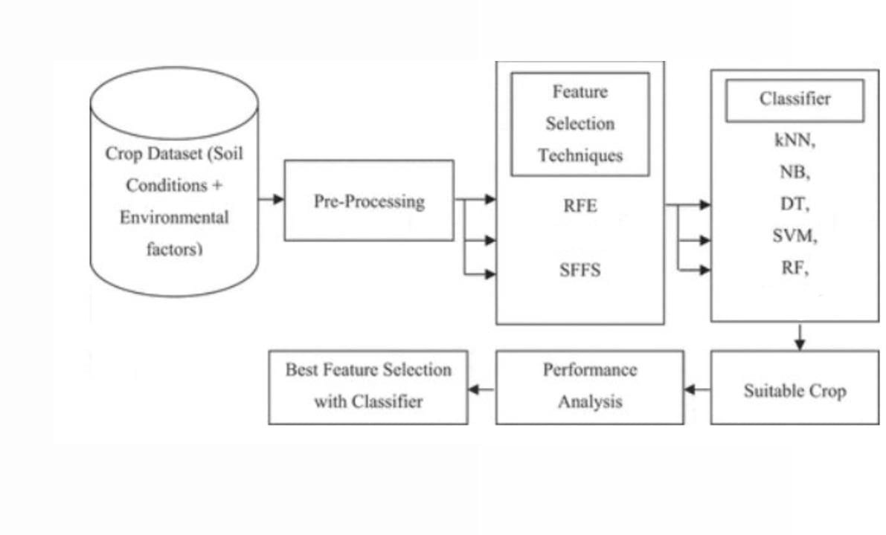practices over time primarily based on converting occasions.

# Conclusion

In end, the crop prediction app has the capacity to

revolutionize agriculture through imparting farmers with customized, accurate, and dependable suggestions for crop management primarily based on real-time information feeds and system studying algorithms. By integrating with existing technologies generally used by farmers, the app can assist optimize crop yields and increase profitability while also selling sustainable and environmentally pleasant farming practices. With its user- pleasant interface, multilingual support, and strong records safety protocols, the crop prediction app is poised to come to be a valuable device for farmers around the arena, especially the ones in growing nations who can also have confined get entry to conventional agricultural resources. Overall, the crop prediction app represents a full-size opportunity to improve the performance, productiveness, and sustainability of worldwide agriculture.